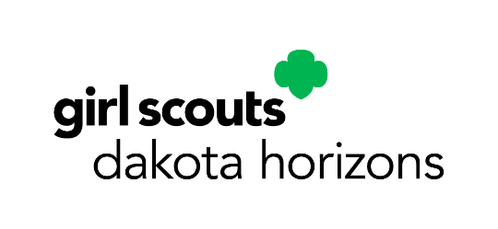

Communicating with Your Project Advisor

This may be your project advisor’s first time being involved with a Gold Award project. So take the opportunity to educate them about Girl Scouts and the Gold Award. Below is a template to help you, though keep in mind that it’s just a jumping-off point—be sure to add your own voice and thoughts! Consider laying out a communication strategy with your advisor from the get-go, based on what works best with your timeline and your advisor’s schedule. Let your advisor know how, and how often, you plan to check in, and because they may have a busy schedule, it can also be helpful to suggest some specific dates in advance.

Dear [PROJECT ADVISOR NAME],

Thank you for volunteering to be my project advisor for my Girl Scout Gold Award project.
I would like to share more with you about what the Gold Award means and what you can expect.

The Gold Award is the highest award that Senior and Ambassador Girl Scouts can earn. In order to become a Gold Award Girl Scout, a girl identifies an issue that’s important to her, then develops and carries out an innovative and sustainable solution with measurable impact. Each project must link to a national and/or global issue.

I plan to earn my Gold Award by addressing [DESCRIPTION OF YOUR CHOSEN ISSUE, WHY IT’S IMPORTANT TO YOU, AND HOW YOU’LL APPROACH IT].

Project advisors play an important role in this process. Although plans and ideas should be my own, I will appreciate any knowledge and advice you can offer along the way.

I would like to check in with you by [YOUR COMMUNICATION STRATEGY]. Please let me know if that makes sense to you.

If you’d like, you can learn more about the Gold Award at girlscouts.org. I have also attached additional information to help you understand the instrumental role you’ll play in supporting my efforts.

Thank you again for your time and support.

Sincerely,

