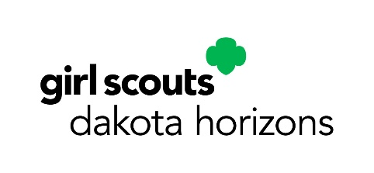
Date

Name of Business
Business Address
Business telephone number
Cookie Program Dates: February 9 - March 23, 2026

Attention: Business Manager

Dear XXXX:

The annual Girl Scout Cookie Program is about so much more than just delicious cookies! Through selling cookies, girls gain priceless skills and confidence. Every time a Girl Scout plans her sales, interacts with customers, or works with her team, she’s building a lifetime of leadership, teamwork, and business skills.

Participating in the cookie program teaches goal setting, decision-making, money management, people skills, and business ethics—skills that are essential not just for success in Girl Scouting, but for life. It empowers girls to develop confidence, determination, and the ability to make a positive impact on themselves, their families, and their communities.

Cookie Booths play a crucial role in this program’s success. By allowing troops to host a booth at your business, you’re supporting girls’ growth and helping sustain the financial literacy program that funds activities for Girl Scouts in your community.
Your support makes a real difference—thank you for helping our girls thrive!

Troop XXXX requests a booth at the time listed below.

- Include dates and times

Thank you for supporting the Girl Scouts and our local community.

Sincerely,

Troop Leader’s name
Troop number
Girl Scouts Dakota Horizons
Phone number
Email address

