**Inviting Girls to Join | Social Media Caption Sample:**

Is your girl looking to make new friends, get active in her community, and have fun? Then Girl Scouts is the place for her! In Girl Scouts, your girl will shine in confidence boosting, girl-approved exciting experiences. You’re invited to join our troop at our next troop meeting! We meet on [ENTER MEETING DAYS AND TIMES]. This troop is made up of girls in grades [ENTER GRADES] from the [ENTER COMMUNITY NAME] area. Reach out to me for more information!

**Social Media Images:**

[**[Download images**](https://girlscoutsrv.box.com/s/1a1h8mbt6i71tz6fplnaukvceat8ujkj)[**here]**](https://girlscoutsrv.box.com/s/1a1h8mbt6i71tz6fplnaukvceat8ujkj)

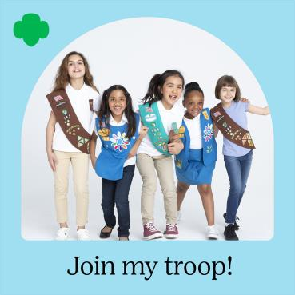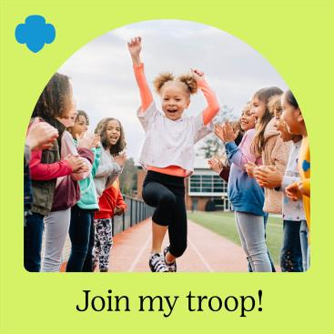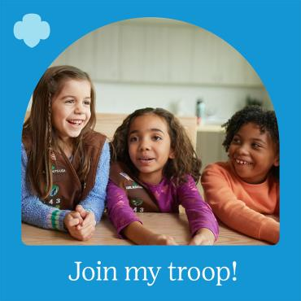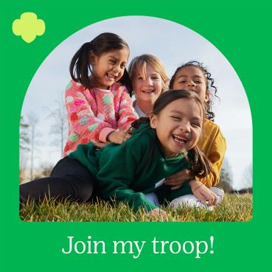

**Inviting Adults to Join | Social Media Caption Sample:**

Help girls make friends, plan new adventures, and build a better world with Girl Scouts. Be the one who brings people together by teaming up with a friend or neighbor to start a Girl Scout troop. Girl Scouts is about fun, learning, and sisterhood, and if you’re organized, kind, and welcoming, you would make a great Girl Scout troop leader! Learn more at gsdakotahorizons.org.

**Social Media Images:**

[**[Download images**](https://drive.google.com/drive/folders/1T4DSPJIwCkPy36NkneBG6rwSXQTx_HOn?usp=sharing) [**here]**](https://girlscoutsrv.box.com/s/1a1h8mbt6i71tz6fplnaukvceat8ujkj)

